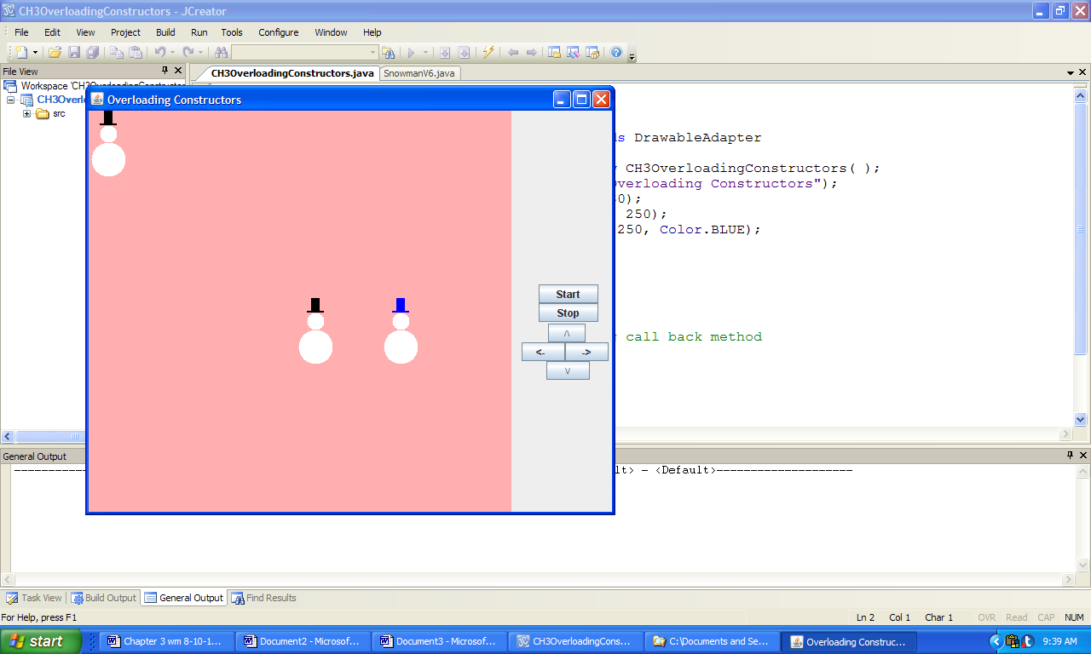

**Figure 3.37 The output from the application OverloadingConstructors.**